**This submission is original work and no part is plagiarized** (signed) Gaurav Pahwa

(Date) 01/09/2021



**MECHANICAL ENGINEERING DEPARTMENT**

**Thapar Institute of Engineering and Technology, Patiala**

**Assignment - 3.**

**Design against failure under *static* actions**

***UTA016 Engineering Design Project-I***



**Assignment - 3**

**Structural Engineering Component**

**Design against failure under *static* actions**

Complete the following **individually, copying will be dealt with severely.**

**Instructions:**

1. Data to be used for excel spreadsheets graphs to be created for Q1, Q2 and Q3 is (will be provided by the respective lab instructors):

|  |  |  |  |  |
| --- | --- | --- | --- | --- |
| **Exp. No** | **Span,**  **L mm** | **Width,**  **b mm** | **Height,**  **d mm** | **Failure load, mass kg** |
| 1 |  |  |  |  |
| 2 |  |  |  |  |
| 3 |  |  |  |  |
| 4 |  |  |  |  |
| 5 |  |  |  |  |
| Average |  |  |  |  |

1. **Excel spreadsheets graphs to be created for Q1 and Q2 will evaluated by end of tutorial class**. Remaining questions is to be submitted before next tutorial class (if it is a holiday, then as instructed).

Despite this list, try and enjoy the assignment and try to think around the subject as much as possible and take from it any tips that you might use with your own Catapult.

**When you have built your own mangonel, with your own choice of rotating arm, L2 part (i.e. spoon: material, diameter and length) and having measured the rotational velocity on impact using the electronic component of this project, then the procedures in Assignments 3 and 4 should allow you to make a reasonable prediction as to whether your chosen arm is likely to fail statically when fully loaded or dynamically when the missile is released. It would clearly be desirable to avoid an unexpected structural failure of any part during the final showcase.**

**Marking Scheme: Assignment 3 (5 Marks)**

1. **Evaluation at end of Tutorial: 2.5**
2. **Evaluation from printout submission:2.5**
3. From experiments, you measured experimentally the bending stress at failure of a timber beam (**Calculate in Excel sheet the Average Stress at failure for the experiments**). (**Evaluated on laptop, use format below**)

|  |  |  |  |  |  |  |  |  |  |
| --- | --- | --- | --- | --- | --- | --- | --- | --- | --- |
|  | **Measured** | | | | **Calculated** | | | | |
| Exp | Span | Width | Depth | Failure load | Failure Force | M=PL/4 | y=d/2 | I=bd^3/12 | Strength  |
| No | L mm | b mm | d mm | mass Kg | P N | Nmm | mm | mm^4 | MPa(N/mm^2) |
| 1 |  |  |  |  |  |  |  |  |  |
| 2 |  |  |  |  |  |  |  |  |  |
| 3 |  |  |  |  |  |  |  |  |  |
| 4 |  |  |  |  |  |  |  |  |  |
| 5 |  |  |  |  |  |  |  |  |  |
| 6 |  |  |  |  |  |  |  |  |  |
| Av |  |  |  |  |  |  |  |  |  |

1. Using the average strength of wood from Q1 calculate the theoretical variation in failure load, P, when the span of the beam is varied over the range from 100-700 mm, for the same dimensions in Q1, and **draw a plot** of the relationship. (**Evaluated on laptop**)

P=4σI/yL

(Insert the **Excel graph in format given below**).

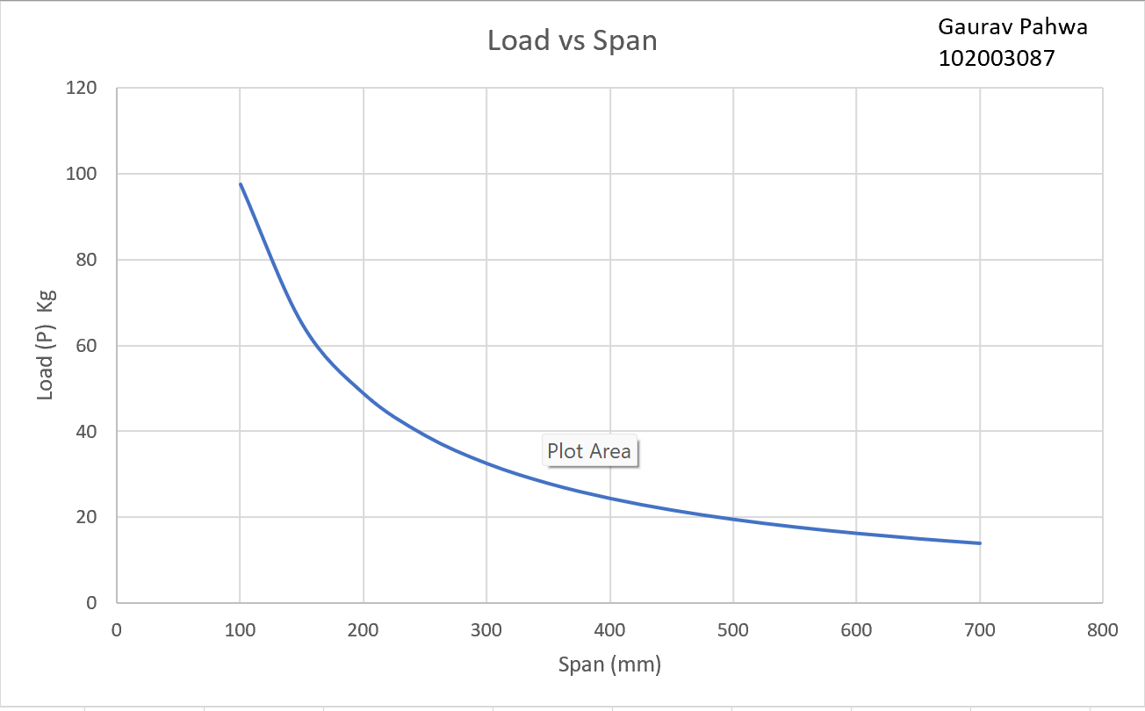

1. Using the average strength of wood from Q1 calculate the theoretical variation in failure load, P, when the cross sectional dimensions of the beam are varied over the range from square of 4-10 mm (for the same span as was used in Q1 and **draw a plot** of the relationship.

(Insert the **Excel graph in format given below**).

P=2σd^3/3L

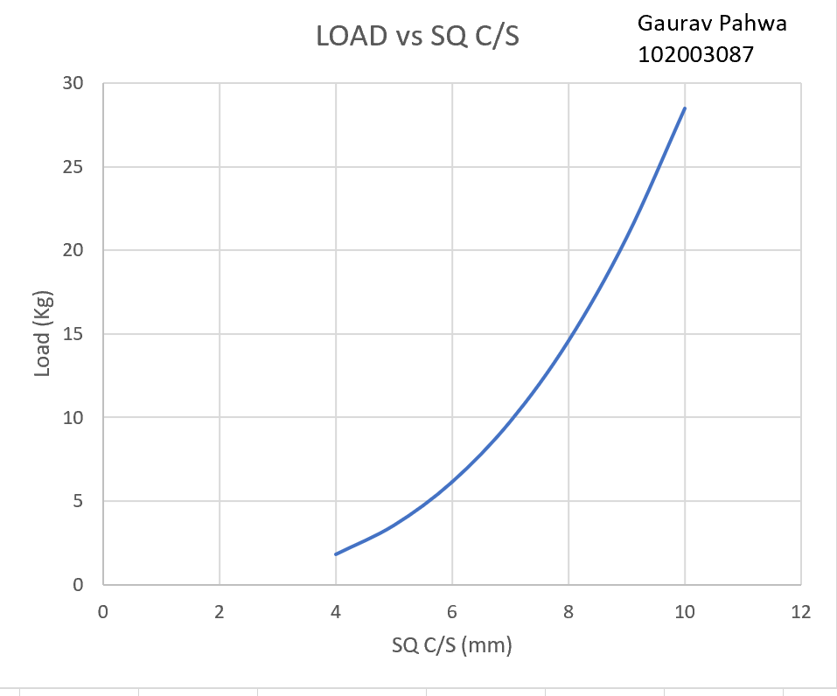

1. For Q1. Assuming the square cross section of 6 mm and a span of L = 200 mm calculate **theoretically** the failure stress (strength) for a simply supported beam which fails due to a 5 kg weight. _____________________________.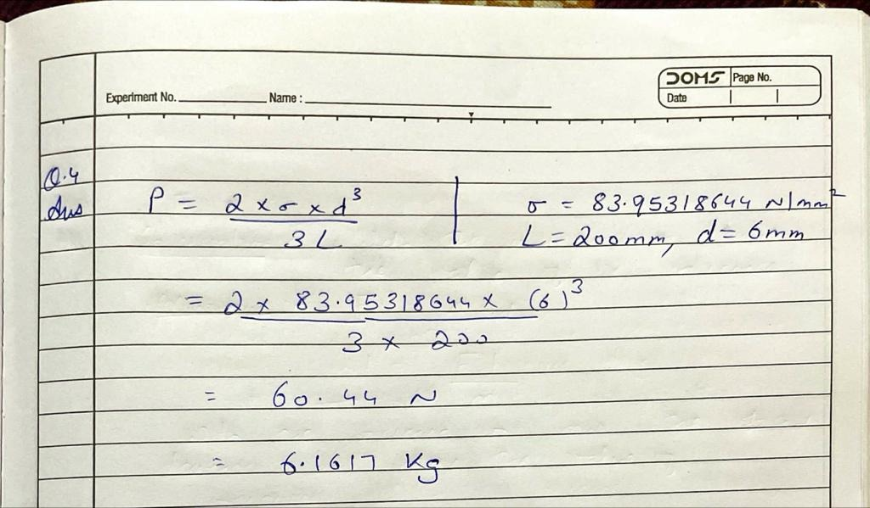
2. A second beam of dimensions 9x9 mm and span L = 500 mm was tested and found to fail at 7 kg. Theoretically, what value should it have failed at? Explain any discrepancy in your result if there is one. What do you learn from this?

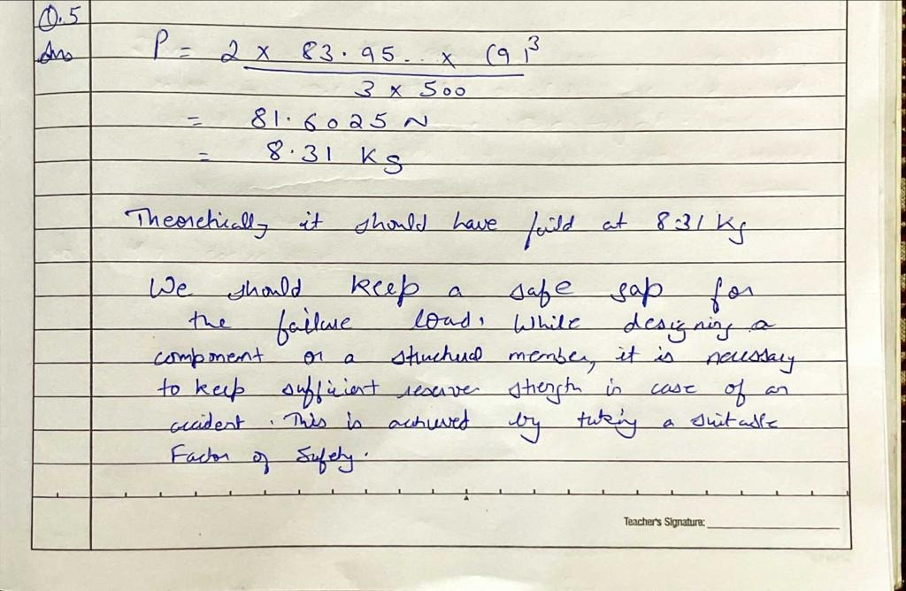

1. What do you observe from the plot of Q2?

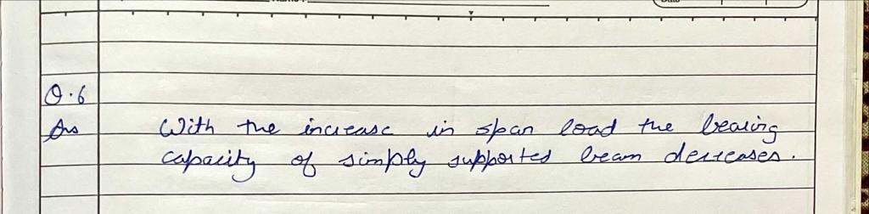

1. What do you observe from the plot of Q3?

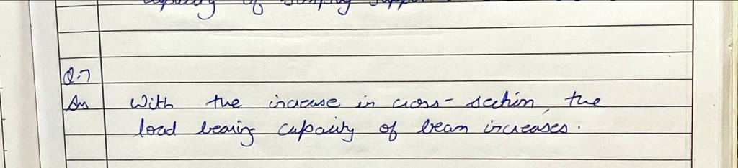

1. **Now let us address the Catapult.** Assume the length of the throwing arm of the Catapult is 240 mm from the axis of rotation to the D-ring. Select the optimum diameter and so that the arm does not fail in bending under static loading. The worst case of static loading is when the arm is fully pulled back and ready to release. You should use a peak static force of 120 N in your calculation. Note! The end conditions of the arm are different to those in class experiments, i.e. it is not simply supported! Refer to notes handout to determine which equation is appropriate for this cantilevered condition. Is the diameter of the throwing arm of 28 mm adequate? Comment. 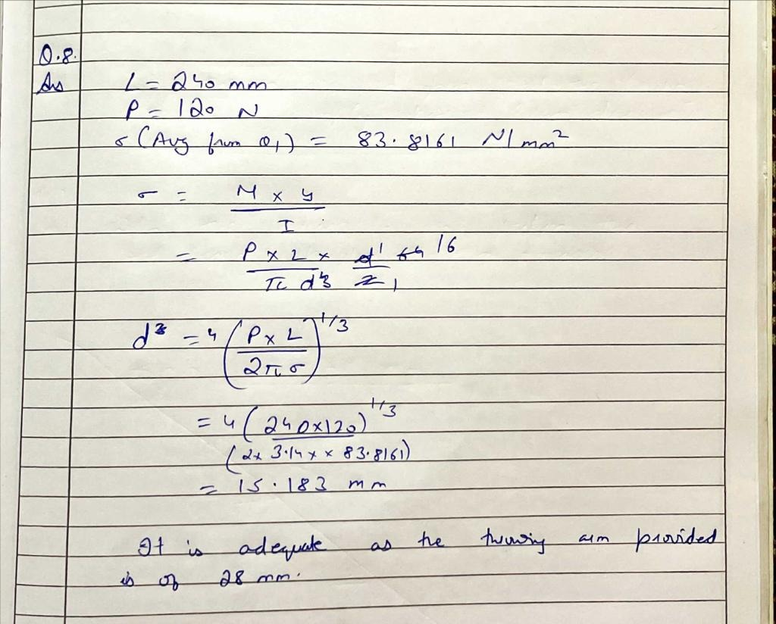
2. For the conditions in Q8:
   1. Can the nylon cable holding the main arm in place, when cocked, resist the force without breaking? What is the FOS? You may assume that the axial failure stress of the cable is 65 MPa (i.e. N/mm2) and that the cable has a circular cross section of diameter 2.4mm. 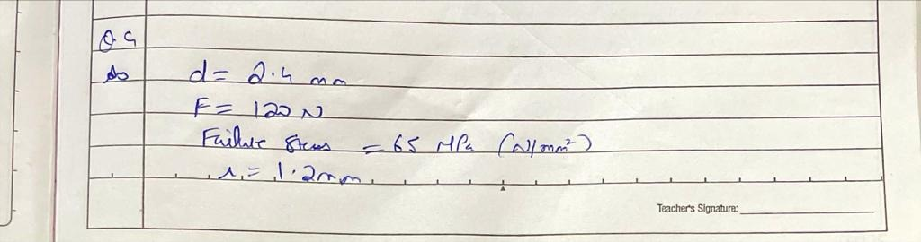
   2. The other end of the cable is attached to a timber dowel 20.5 mm diameter which is held in double shear by the base of the Catapult. Design the minimum diameter of dowel that is required to resist this force without it failing in shear. You may assume the shear stress capacity of the dowel is 15 MPa. What is the FOS of the dowel of your Catapult? 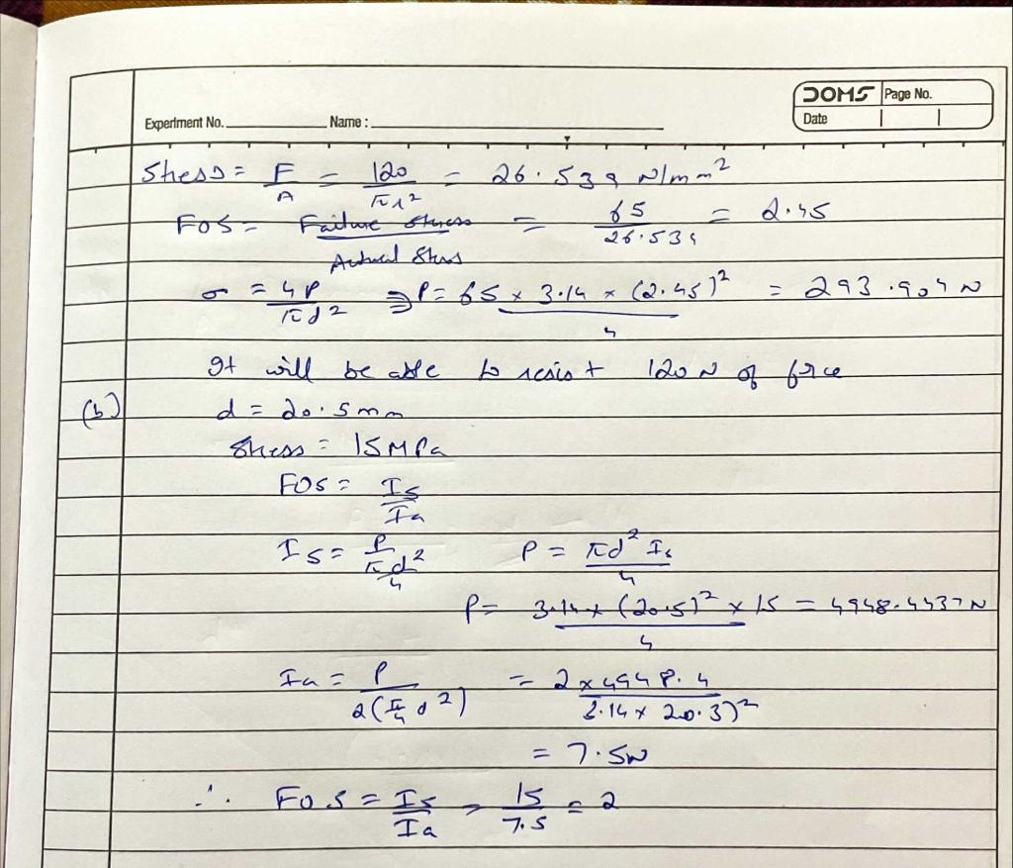
3. Using the library and /or the internet for referencing, compare the strength of timber in bending with a variety of other available materials. Produce a table of the relevant properties and comment on their suitability for use as the main arm in a Catapult. You will use this information as well as the analysis techniques above to help you redesign/optimise the throwing arm.

|  |  |  |  |
| --- | --- | --- | --- |
| Sr No | Material | Strength in Bending | Comment |
|  | Plastic |  |  |
|  | Acrylic |  |  |
|  | Glass |  |  |
|  | Aluminium |  |  |
|  | Stainless Steel |  |  |
|  |  |  |  |

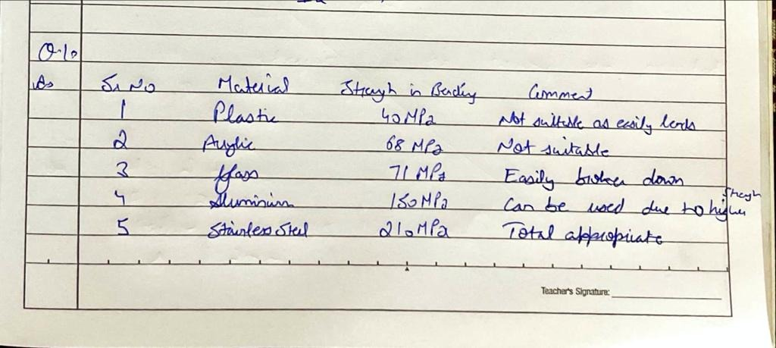

**Note!! The end conditions are different in Q1-Q7 (simply supported) from that of the Catapult (cantilever) in Q8 onwards. The equation for the bending stress will therefore be different!**